SP Path Planning Research Notes – Sam Schneidereith
I worked on this project for 2 years, 2024-2026, for my aerospace honors program research. This work was picked up from Ryan Ernandes who initially looked into sampling-based motion path planning for Stewart Platforms in attempt to minimize state uncertainty for his 2020 master’s thesis. I was initially tasked by Dr. Otte with running Ryan’s code for more test cases to collect more data so that we could ultimately publish the work. Before doing this, I wanted to first understand the research, so I spent my first-year learning about what I call the ‘3 pillars’ of this research: sampling-based motion, Stewart Platforms, and state estimation / filtering. In the fall of my senior year, I began looking at Ryan’s code and had enough literacy on the topic to see some of the major flaws. The first thing I noticed was that the path planning rarely found better paths, so the cost vs time plots were mostly flat lines for each trial.
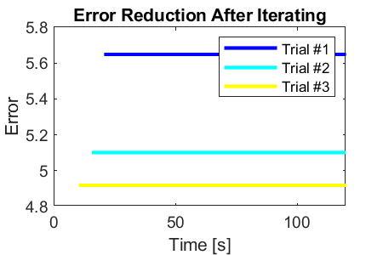
Error vs Time Plot from Ernandis’ Code
I thought this was a pretty significant issue that was mostly ignored in his master’s thesis. In fact, in the thesis, one plot similar to that above appears where every trial is a flatline, but it is not commented on. Most of his plots show box and whisker plots in which there is a reduction in the IQR of the error over the first ~10s but I believe that this is only due to the fact that some fact that some trials hadn’t found paths yet.
This is when I began to look deeper at the code and, I will not go into detail here, but the main test file contained 1500 lines of code within 3 nested for loops, riddled with if statements. There were a few bugs that I began to discover as I scratched the surface but due to the lack of compartmentalization it was nearly impossible to debug/edit. That’s when I made the decision to just completely overhaul it and start from scratch. I referenced his code in writing my own but copied very little. For notes on my code or my notes on Ryan’s code, please see the respective documentation I have written.
When writing my simulation environment, I made a conscious effort to test every ‘pillar’ individually to ensure functionality before I combined everything into this novel application. In the demos folder there is an example of 3D and 6D planning using distance for cost to check the functionality of the planning. *Note that at this point I have not yet written my own Stewart Platform hardware code, so I am still using Ryan’s here. There are slight bugs but for the sake of testing planning it did not matter. This was fixed in the final version of my code. Under SamsCode>Tests, there are some test scripts that I used in development to test the effectiveness of things like the EKF, differential kinematics, and belief propagation. These are not called externally and are not particularly robust but can be looked at if curious.
By early Spring of my senior year, I had created a very robust and compartmentalized simulation environment that is user friendly. More importantly, I demonstrated the behavior that I had hoped to see from the beginning of this research. As shown, the cost consistently decreases and converges.
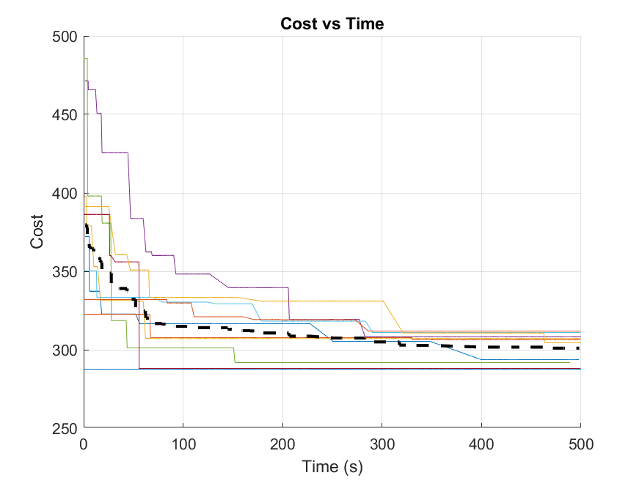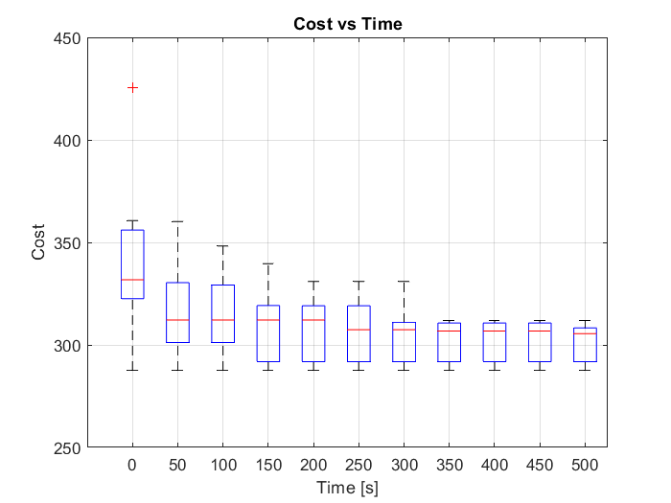
Unfortunately, I did not have the time to do as many experiments as I would have liked and was not able to get this published before graduation. That being said, I believe that I have created an environment for someone to follow and complete what I was initially tasked to do. Before editing any code, please read my documentation, which will hopefully save you a lot of time and effort. I have also appended some of my research notes here which could steer future research or hint at why I made some design decisions.

I hope someone else is able to finish what Ryan and I have started. Please don’t hesitate to reach out with questions or comments to my permanent email below. I would be happy to assist.

Sincerely,
William (Sam) Schneidereith
Email: sam@schneidereith.com

Notes
- The RRT* algorithm implemented in my code is based on the pseudocode in Ryan’s thesis. It is NOT the original RRT* and does not do any rewiring, thus it is not asymptotically optimal. This is somewhat of a non-problem, because RRT# is much more efficient so it was not something I wanted to spend a lot of time reworking. Just make sure to note this for any publication.
- When path planning using path length as your cost function, the shortest path is known, so things like rejection sampling and heuristic conditions can be implemented. When using path uncertainty as the cost function, the lowest-cost path’s geometry is not known (to my knowledge). In fact, in my honor’s thesis I demonstrate how path length has little to no significance on the best path. For this reason, I was not able to implement rejection sampling or a heuristic condition.
- An issue that occurred to me after writing and presenting my research is that, while we normalize angles wrt positions in distance calculations, no such thing is being done when calculating / comparing error covariance matrices. This only occurred to me after seeing that the ellipsoid volumes were on the order of 10^-5. This means that when using trace, the angle uncertainty is completely overshadowed by position uncertainties on the order of 0.1. I haven’t implemented any sort of solution and leave this as an exercise for the reader however my idea at the moment is to multiply the angles by w (the normalization constant) when calculating trace. For the volumetric function, we are using more than just the diagonal entries so the solution might be slightly more involved. I feel that this is one of the biggest Achilles heels at the moment and I am hoping that it does not significantly change results.
- A lot of the clutter in my code came from data collection for plotting. It pained me a little because I could not find a clean way to collect all of the plotting data I needed, so it is one of the parts I am least proud of.
- In a meeting with Dr. Otte here were some of the plots that would be great for a publication:
  - Run many trials and plot the standard deviations
  - Plot a scatter plot for final paths where one axis is cost and the other axis is path length. Would be interesting to prove the presence or absence of a correlation between the two.
  - Trace and Volumetric cost functions are both implemented, so one of the more complex plots we discussed would be a scatter plot where one axis is cost using trace and cost using ellipsoid volume. There would be two series of points: one series would be trials planned using trace and at the end the best path cost would also be calculated using volume, and for the other series vice versa. Each point in each series would correlate to a point in the other series by matching start and goal states. A line would be drawn between these correlating points to see if there are any trends. Below is a whiteboard drawing of what this may look like:

